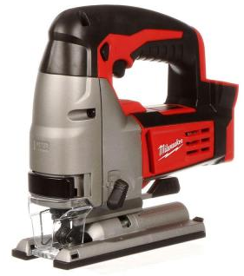
JIG SAW &
RECIPROCATING SAW
- Always wear safety glasses. Hearing protection is optional.
- Disconnect power before changing blades. Use blades designed for the material being cut. If cutting metal, use cutting oil to extend blade life.
- These saws cut on the upstroke (when it’s moving towards the tool) so it’s important to keep the shoe (recip) or the base (jig) against the material.
- Clamp material to work surface if possible. Be conscious of the path of the blade and what is behind the material being cut. Keep cord out of the way.
- Blade should be moving at full speed before engaging the cut.
- Apply an even pressure as you cut. Course corrections are harder with bigger blades so sometimes it’s easier to back up and start over.
- If you want to start your cut inside the material use a drill to make a hole and then insert the saw blade through the hole.
- Be mindful of the blade even after you release the trigger.

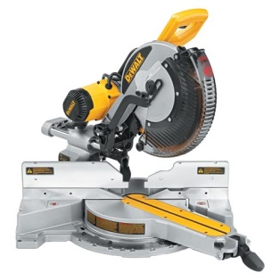
MITER SAW
- Always wear safety glasses. Hearing protection is recommended.
- Disconnect power before changing blades or cleaning.
- With the tool unplugged check for proper blade rotation and that the blade guard is working properly.
- Make sure that material being cut is sitting firmly against the fence and deck.
- One hand will operate the trigger/handle and the other will stabilize the material being cut. Keep hands away from blade, use clamps when possible, avoid crossing your arms in front of the blade.
- Blade should be moving at full speed before engaging the material.
- Push the blade slowly and smoothly through the material. Let the saw bottom out and release the trigger. Allow blade to stop before raising the handle.
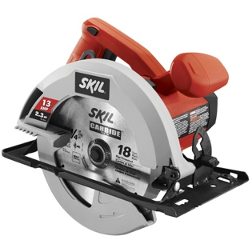
CIRCULAR SAW
- Always wear safety glasses during operation. Hearing protection is recommended.
- Disconnect power before changing blades, cleaning blade guard, or adjusting depth of cut.
- With the tool unplugged check for proper blade rotation and that the blade guard is working properly.
- Set depth so that the blade only extends 3/8 inch beyond the material being cut.
- Clamp material to work surface if possible. Be conscious of the path of the blade and what is behind the material being cut. Keep cord away from path.
- Clamp a guide rail to your material if possible. Saw will ride against the rail.
- Keep both hands on the saw – one on the trigger and one on the front knob.
- Blade should be moving at full speed before engaging the material.
- Do not force the cut. NEVER back up with a circular saw. Strong course corrections and backing-up can pinch the blade and cause kick-back. If you need to make a course correction or have over extended your reach, release the trigger, let the saw come to a complete stop and reposition yourself.
- Be mindful of the blade after you release the trigger.

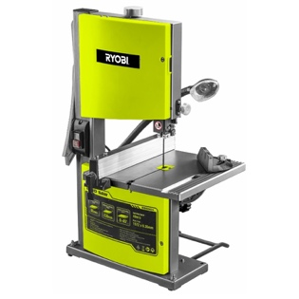
BAND SAW
- Always wear safety glasses during operation. Hearing protection is optional.
- Set the blade guard so that 3/8 inch of the blade is exposed above the material.
- Blade should be moving at full speed before engaging the material
- Hold material firmly with both hands against the deck.
- Do not reach for off cuts with your hand, use a scrap piece of wood.
- Do not use excessive force when pushing material through and avoid tight turns.
- Cover blade and turn off machine when not in use.

HAMMER DRILL
- Always wear safety glasses. Hearing protection and gloves are recommended.
- Make sure correct drill bit is being used and is secured in the chuck. Righty tighty, lefty loosey.
- Press trigger and apply a medium and consistent pressure against the drill. You don’t need to push too hard, let the drill do the work for you.

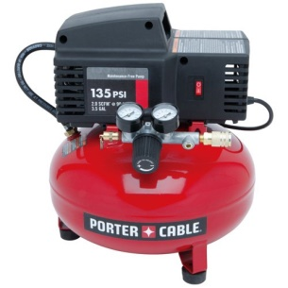
AIR COMPRESSOR
- After plugging in compressor and turning it on let the machine run until the tank is full. Compressors will turn themselves on and off automatically to maintain a full tank (somewhere between 120-150psi)
- Compressors have two gauges, one for tank pressure and one for outlet pressure. Outlet pressure can be adjusted by twisting the knob.
- Connect hose to outlet of compressor into your tool and set pressure to ~100psi
- After your project is complete, drain all the air out of the tank.

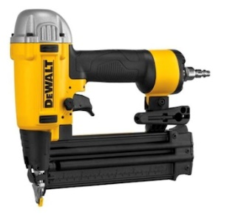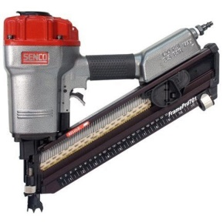
PNEUMATIC NAILERS
- Always wear safety glasses during operation, hearing protection is recommended.
- Make sure you have the right gauge nails (15, 16, 18 or narrow crown staple) and that it is the appropriate length for the tool and your project. Information about the tool is often printed on the side of the nail cartridge.
- Attach to hose coming from the outlet of the compressor making sure cartridge is empty and gun is pointing away from people/animals.
- Clamp workpiece when possible, otherwise keep hands and fingers away from where nailer is placed. If the nail is 1 ½” keep your hands 3” away.
- Press nailer against workpiece to disengage safety switch and press trigger
- If nail does not go below the surface of the workpiece, increase pressure.

